2023 Week of Prayer for Christian Unity

Do good; seek justice (Isaiah 1:17)

Abridged Order of Worship

Introduction to the Abridged Order of Worship
The 2023 WPCU international and Canadian resources are available to download at: weekofprayer.ca/2023-wpcu-resources (English)
semainedepriere.ca/fr/ressources-pour-la-spuc-2023 (French)

The Abridged Order of Worship is a shortened version of the full Order of Worship. It can be used in post-secondary settings or with communities that require a shortened service. Without a sermon, the service will take approximately 30 minutes, depending on the speakers and choice of hymns and music (options are available at the end of the package). It also requires fewer readers, a reflection that the congregation may be smaller.

The Abridged Order of Worship is also an opportunity for students to experiment with wording alterations and liturgical decisions. Please change the language or actions as necessary to suit your community’s needs. For ideas, please see the Annotated Order of Worship.

The river/water motif has strong cultural relevance for the local committee designing these worship resources. For the Minnesotan context the river and water have meant both cultural genesis and genocide at points in the history of this region: http://www.afn.ca/honoring-water/

We encourage you to be creative in your use of the Week of Prayer for Christian Unity resources! For example, you may wish to alter the ecumenical worship service to better suit the context of your community, or you may draw inspiration from the WPCU materials to create something entirely new. Communities should also feel free to use the WPCU materials not only during the traditional Week of Prayer for Christian Unity (January 18-25 in the northern hemisphere), but throughout the year, to pray for Christian unity and to foster ecumenical fellowship and service.

Abridged Order of Worship

L Leader
R Reader
C Congregation

Prelude

Traditional Territorial Acknowledgement

Call to Gather (or Call to Worship)

L All, we gather here in the name of the Father, and of the Son, and of the Holy Spirit.

As we gather, let us reflect on our actions and inactions and learn to do good and seek justice.

We need God’s grace to overcome our divisions and to uproot systems and structures that have contributed to the fracturing of our communities.

We gather to pray to reinforce the unity that we have as Christians to “open our hearts, that we may be bold in finding the riches of inclusion and the treasures of diversity among us. We pray in faith.”

Invitation to Confession and Forgiveness

Confession and Forgiveness through the Reading of Isaiah 1:12-18

R We are invited to confess our sins with the words of the prophet Isaiah.

When you come to appear before me, who asked this from your hand? Trample my courts no more; bringing offerings is futile; incense is an abomination to me (12 – 13a).

C Forgive us Lord when we come to worship without walking humbly before you.

Silence

R New moon and Sabbath and calling of convocation – I cannot endure solemn assemblies with iniquity. Your new moons and your appointed festivals my soul hates; they have become a burden to me, I am weary of bearing them (13b – 14).

C We ask forgiveness for the complicity of churches in the evils of colonialism felt around the world.

Silence

R When you stretch out your hands, I will hide my eyes from you; even though you make many prayers, I will not listen; your hands are full of blood. (15)

C We ask forgiveness for our sins of injustice and oppression that suppress the diverse harmony of your creation.

Silence

(At the font, the presider slowly pours a pitcher of water into the font or a basin during the reading.)

R Wash yourselves; make yourselves clean; remove the evil of your doings from before my eyes; cease to do evil, learn to do good; seek justice, rescue the oppressed, defend the orphan, plead for the widow. (16, 17)

C As we have been washed clean in the living waters of baptism, forgive us anew and reconcile us to one another and to creation.

Silence

R Come now, let us argue it out, says the Lord: though your sins are like scarlet, they shall be like snow; though they are red like crimson, they shall become like wool. (18)

L May God, in his mercy, free you from your sins so that you can do justice, love kindness, and walk humbly with your God.

Silence

L Almighty God hears our prayers, has mercy on us and forgives our sins.

C Thanks be to God.

Prayer

L God of all, our hearts and bodies are thankful for this opportunity to come before you to confess our sins of injustice and divisiveness.

Together we come before you, a holy family, united in the beautiful diversity of your creation: some of us are Indigenous peoples, some of us are descendants of the enslaved, some of us are descendants of the enslavers, some of us are migrants, some of us are refugees, but all of us are part of the one Body of Christ.

We praise you that through the living waters of baptism our sins, red as scarlet, were washed away and we were healed, as we became part of the beloved community, the family of God. We offer our thanksgiving and praise to you, Creator God.

Together on this journey, we celebrate with our hearts and eyes open to understanding and growing in the sacred wisdom that is shared and passed amongst all people. Help us to embrace unity with each other, and remind us that we are of one family gathered by your Holy Spirit, in the midst of your creation. Amen.

Hymn

Psalm 42 (responsively)

R As a deer longs for flowing streams, so my soul longs for you, O God.
My soul thirsts for God, for the living God.
When shall I come and behold the face of God?
C Hope in God; for I shall again praise him.
R My tears have been my food day and night, while people say to me continually,
“Where is your God?”
These things I remember, as I pour out my soul:
how I went with the throng, and led them in procession to the house of God,
with glad shouts and songs of thanksgiving, a multitude keeping festival.
C Hope in God; for I shall again praise him.
R Why are you cast down, O my soul, and why are you disquieted within me?
Hope in God; for I shall again praise him, my help and my God.
My soul is cast down within me;
C Hope in God; for I shall again praise him.
R By day the Lord commands his steadfast love, and at night his song is with me,
a prayer to the God of my life.
I say to God, my rock,
“Why have you forgotten me?
Why must I walk about mournfully because the enemy oppresses me?”
C Hope in God; for I shall again praise him.
R As with a deadly wound in my body, my adversaries taunt me,
while they say to me continually, “Where is your God?”
Why are you cast down, O my soul, and why are you disquieted within me?
C Hope in God; for I shall again praise him.

Gospel Reading Matthew 25:31-40

Hymn

Prayers of Intercession

L With faith and confidence, we come in prayer, before God, who is Father, Son, and Holy Spirit:

Creator God, today we live with the consequences of actions that have made life unsustainable for some and overabundant for others. Teach us to know how to use responsibly the resources you have given to us for the benefit of all and the respect of your creation. The groaning creation cries out to you.
C Teach us and show us the way.

L Compassionate God, help us repair the harm that we have inflicted upon each other and the divisions we have created among your people. Just as Christ Jesus breathed the Holy Spirit onto the disciples to birth the community of the new creation, send your grace to heal our divisions and gift us with the unity for which Jesus prayed.
C Teach us and show us the way.

L Christ, the way, the truth and the life, you embodied justice in your ministry on earth by the good that you did, breaking down the walls that divide and the prejudices that imprison. Open our hearts and minds to recognize that though we are many, we are one in you.
C Teach us and show us the way.

L Holy Spirit, you create anew the face of the earth. The summit of the mountains, the thunder of the sky, the rhythm of the lakes speak to us –
C Because we are connected.

L The faintness of the stars, the freshness of the morning, the dewdrops on the flower speak to us –
C Because we are connected.

L The voices of the poor, the oppressed and the marginalized speak to us –
C Because we are connected.

L But above all, our hearts soar to you for we cry out ‘Abba, Father’ as we say:

C Our Father.… Lord’s Prayer or Prayer of Jesus

Closing Prayer

L Everlasting God, look upon these faces gathered together in holy community and send them anywhere you would have them go.

Encourage them by your Holy Spirit to continue to tell their stories, to do good, and to seek justice for the sake of your Creation through their actions.

Sustain them that they may be one, so the world may believe that you sent your only Son Jesus for the life of the world.

Sending Forth

L The Lord bless you and keep you;
The Lord make his face shine on you and be gracious to you.
The Lord lift up his countenance upon you.
And give you peace.
C Amen.

Hymn

APPENDIX*

Hymn Many and great, O God (Dakota Hymn)
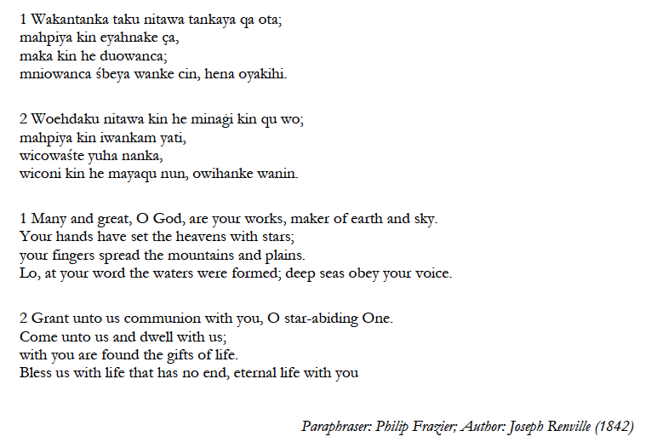

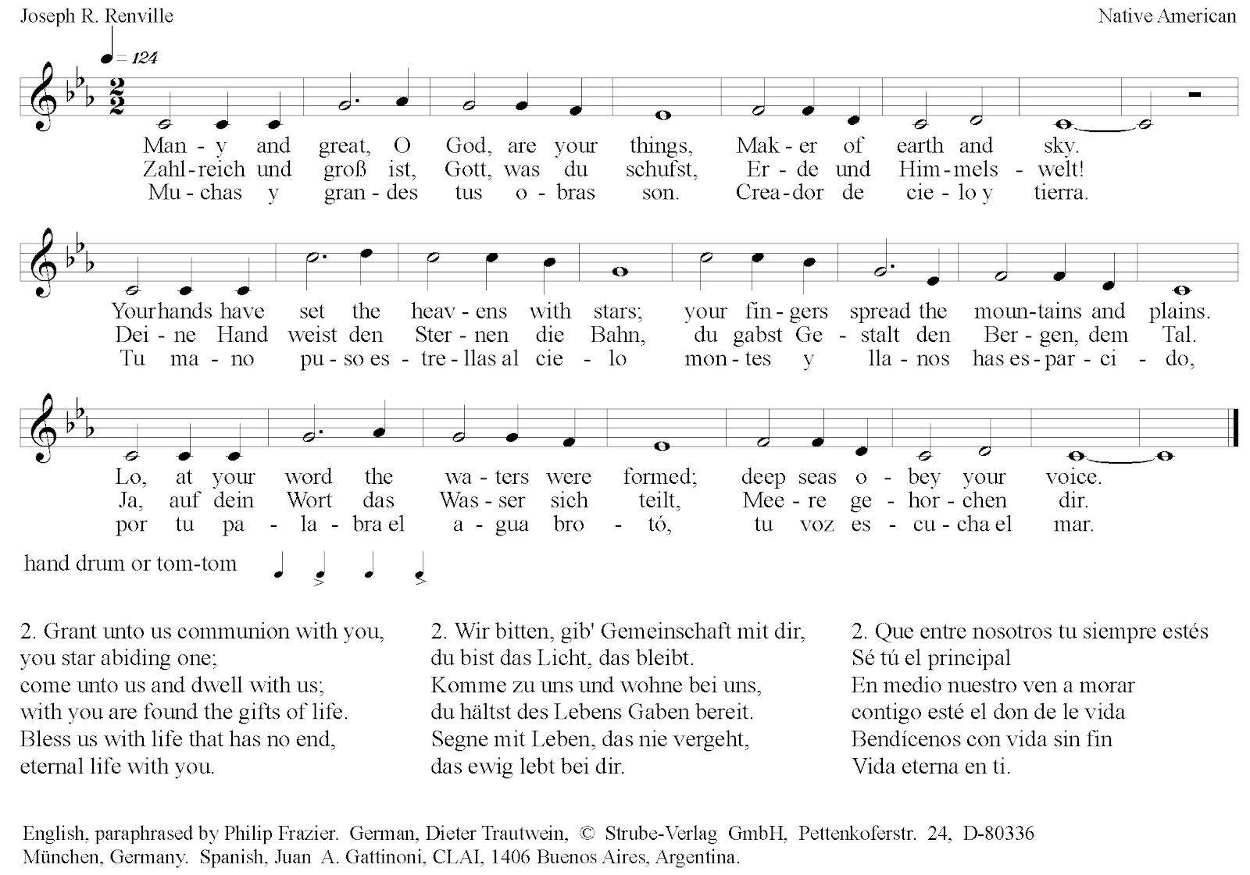

Hymn Wade in the water
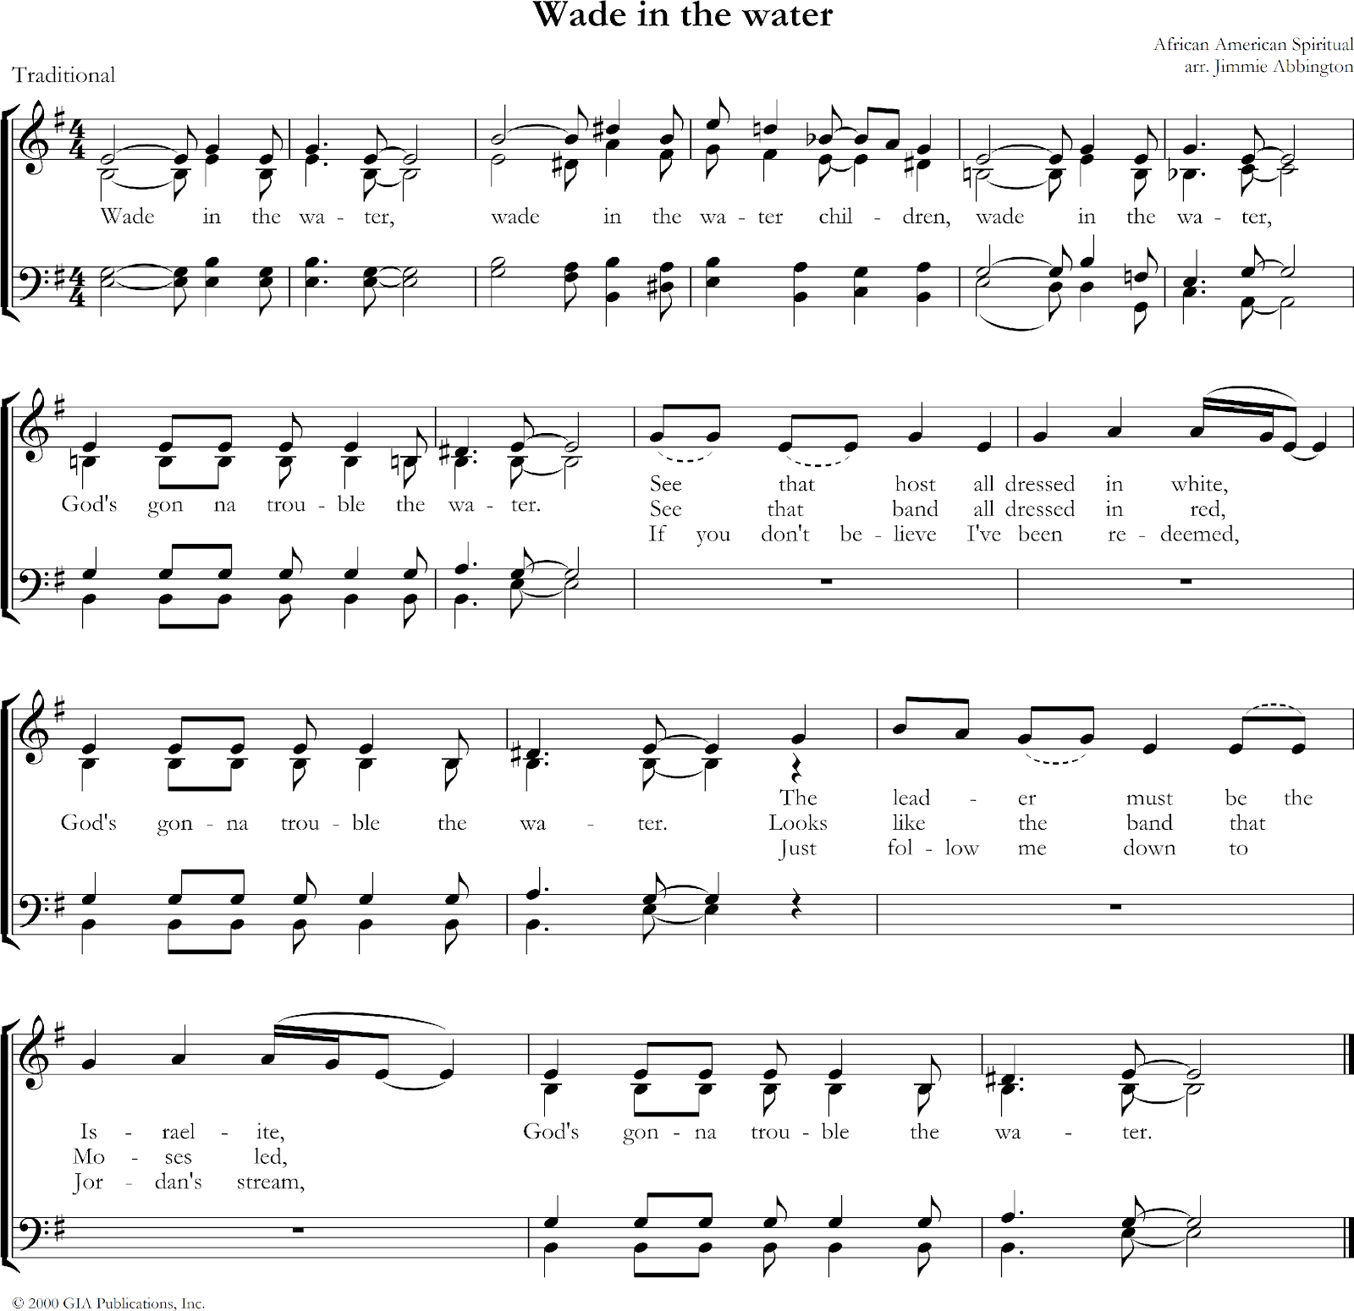

Hymn Come thou fount of every blessing

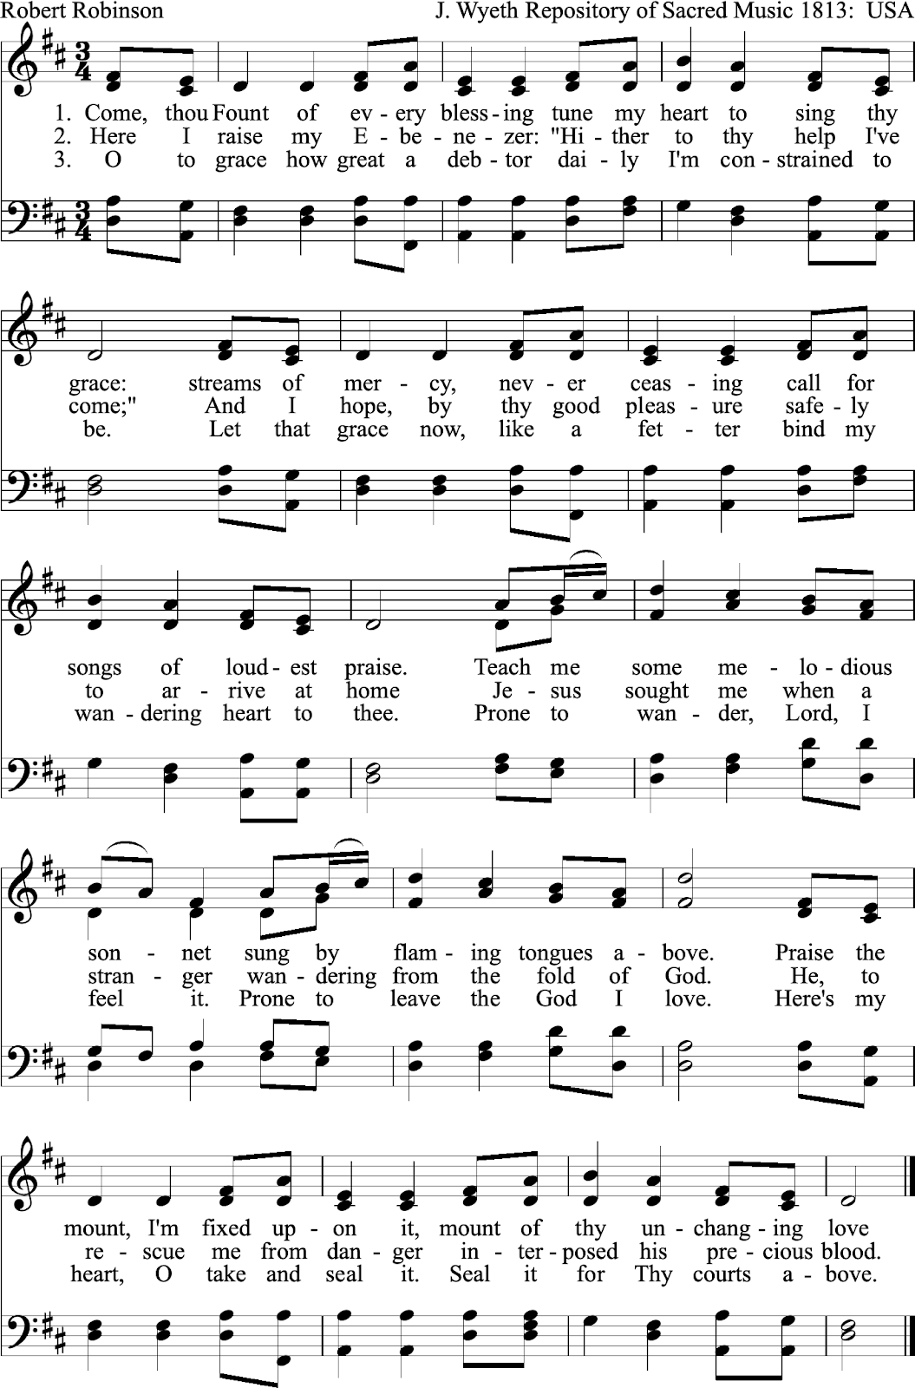

Hymn What a fellowship, what a joy divine

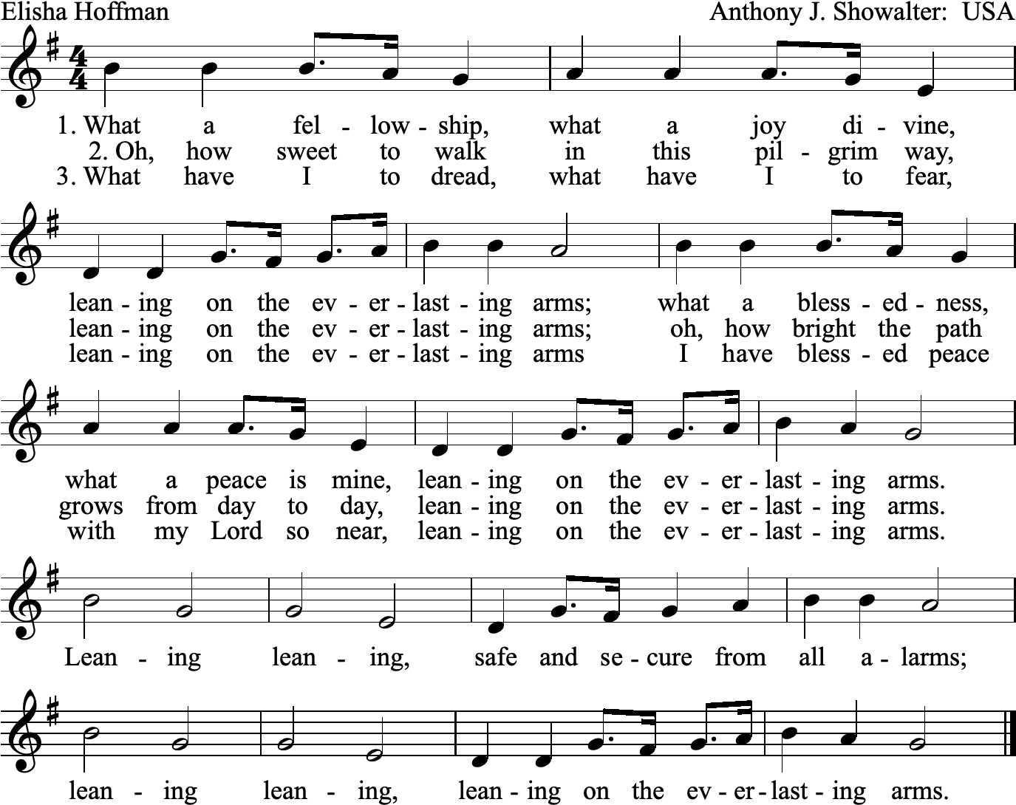

Closing Hymn Lift every voice and sing

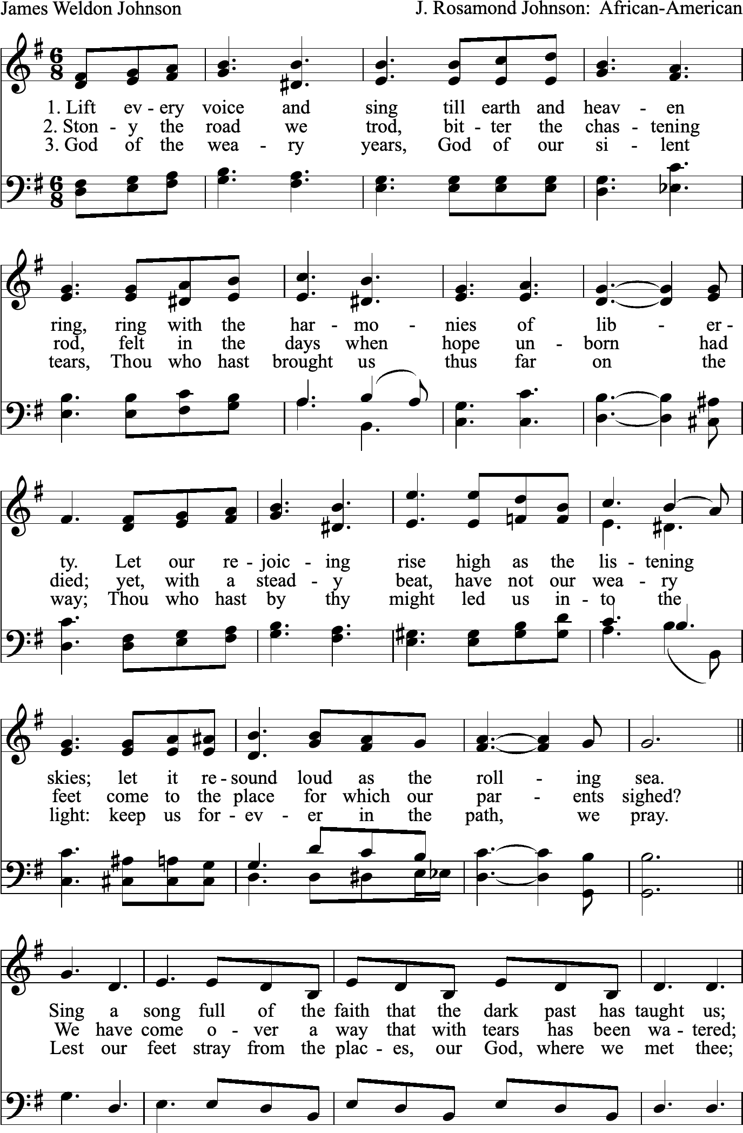

Revd Dr Martin Luther King Jr.
* These hymns have been suggested by the writing group from the Minnesota Council of Churches, which prepared the first project of the Week of Prayer for Christian Unity 2023, and are published under their responsibility.
This hymn was sung by thirty-eight Dakota prisoners of war as they were led to execution at Mankato, Minnesota, on December 26, 1862. This song was first published in the Dakota Indian Hymnal (1916) and is perhaps the only Native American hymn to be sung broadly in North America beyond its original Dakota culture. The author, Joseph Renville, was indigenous Dakota and the translator of this hymn is Francis Philip Frazier.
This is an African American Jubilee Spiritual by Frederick J. Work, John Wesley Work Jr. (1901), based upon the narrative of John 5:2-9. For the enslaved, this song represented the struggles of life and the empowerment of freedom. Within the context of the ‘troubled’ waters of life there are healing waters, because God is in the midst of the turmoil.
This hymn, authored in 1887 by E. A. Hoffman, was inspired by Deuteronomy 33:27. It is meant to help contemplate what it means to find refuge in our heavenly Father's arms in times of fear and trial, and to allow God’s joy and peace to replace our loneliness and anxiety.
This is an African American Jubilee Spiritual which was written by James Weldon Johnson (1900). It is often referred to as the Black national anthem in the United States. The song is a prayer of thanksgiving for faithfulness and freedom for the enslaved voicing a cry for liberation and affirmation for African American people.

