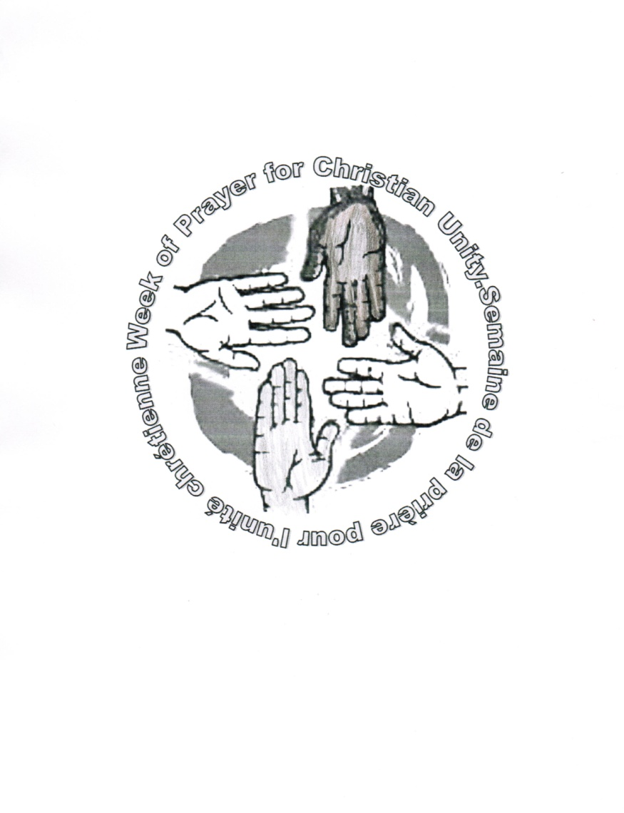**Worship Service**

***Your right hand, O LORD, glorious in power* (Ex 15:6)**

**Gathering**

***Gathering / processional / opening song***

*During the singing of the opening song, those leading the celebration enter, led by a participant carrying a Bible. This Bible is placed in a place of honour in the centre of the worship space. The Scripture readings during the service should be proclaimed from it.*

***Words of Welcome***

*Leader:* The grace of our Lord Jesus Christ, the love of God,

and the fellowship of the Holy Spirit be with you all.

***All:* And also with you.**

*Leader:* Dear friends in Christ,

as we gather for this service of prayer for unity,

we thank God for our Christian heritage,

and for his liberating and saving action

in human history.

The resources for this year’s Week of Prayer for Christian Unity have been prepared by the churches of the Caribbean. The history of Christianity in that region contains a paradox. On the one hand, the Bible was used by colonizers as justification for the subjugation of the original inhabitants of these lands, along with others who were transported from Africa, India and China. Many people suffered extermination, were put in chains and enslaved, and were subjected to unjust labour conditions. On the other hand, the Bible became a source of consolation and liberation for many who suffered at the hands of the colonizers.

Today, the Bible continues to be a source of consolation and liberation, inspiring the Christians of the Caribbean to address the conditions that currently undermine human dignity and quality of life. As the iron chains of enslavement fall from our hands, a new human bond of love and communion emerges in the human family, expressing the unity prayed for by our Christian communities.

**Invocation of the Holy Spirit**

*The response to the invocation may be sung.*

*Leader:* With the Christians of the Caribbean,

let us call upon the Holy Spirit to set our hearts on fire

as we pray for the unity of the Church.

Unite your servants in the bond of unity.

***All:* Come, Holy Spirit!**

*Leader:* Teach us to pray.

***All:* Come, Holy Spirit!**

*Leader:* Liberate us from the slavery of sin.

***All:* Come, Holy Spirit!**

*Leader:* Help us in our weakness.

***All:* Come, Holy Spirit!**

*Leader:* Restore us as your children.

***All:* Come, Holy Spirit!**

***Song of praise***

**Prayers of Reconciliation**

*Leader:* We have not received a spirit of slavery

to fall back into fear.

Let us call upon the mercy of God,

confident in the saving power of God’s Right Hand.

*Three members of the assembly come forward, each carrying a chain. After each petition and response, one of the chains is allowed to fall to the ground. The* Kyrie *response may be sung.*

*Leader:* From structures that undermine human dignity

and enforce new forms of enslavement, deliver us, O God.

Kyrie eleison.

***All:* Kyrie eleison.**

*Leader:* From decisions and deeds that impose poverty, marginalisation or discrimination

on our brothers and sisters, deliver us, O God.

Kyrie eleison.

***All:* Kyrie eleison.**

*Leader:* From the fear and suspicion

that separate us from each other

and place limits on hope and healing,

deliver us, O God.

Kyrie eleison.

***All:* Kyrie eleison.**

*Leader:* The Lord is our strength and our might,

and has become our salvation.

May God, who has redeemed us,

lead us into the abode of holiness.

***All:* Amen.**

**Proclamation of the Word of God**

*Leader:* Redeem us, O God, from human oppression,

***All:* that we may keep your precepts.**

*Leader:* Make your face shine upon your servants,

***All:* and teach us your statutes**. *(cf. Ps 119: 134-135)*

**Reading: *Exodus 15:1-21***

*At the conclusion of the reading:*

*Reader:* Listen and you will be set free.

***All:* Thanks be to God.**

*The psalm may be sung or said.*

***Psalm 118: 5-7, 13-24***

**Refrain: O give thanks to the Lord, for he is good;**

**his steadfast love endures for ever!**

Out of my distress I called on the Lord;

the Lord answered me and set me in a broad place.

With the Lord on my side I do not fear.

What can mortals do to me?

The Lord is on my side to help me;

I shall look in triumph on those who hate me. ***Refrain***

I was pushed hard, so that I was falling,

but the Lord helped me.

The Lord is my strength and my might;

he has become my salvation.

There are glad songs of victory in the tents of the righteous. ***Refrain***

The right hand of the Lord does valiantly;

the right hand of the Lord is exalted;

the right hand of the Lord does valiantly.

I shall not die, but I shall live,

and recount the deeds of the Lord. ***Refrain***

Open to me the gates of righteousness,

that I may enter through them

and give thanks to the Lord.

This is the gate of the Lord;

the righteous shall enter through it. ***Refrain***

I thank you that you have answered me

and have become my salvation.

This is the Lord’s doing;

it is marvellous in our eyes.

This is the day that the Lord has made;

let us rejoice and be glad in it. ***Refrain***

**Reading: *Romans 8:12-27***

*At the conclusion of the reading:*

*Reader:* Listen and you will be set free.

***All:* Thanks be to God.**

*A suitable* **Alleluia** *acclamation may be sung before and after the proclamation of the Gospel.*

**Reading: *Mark 5:21-43***

*At the conclusion of the reading:*

*Reader:* Listen and you will be set free.

***All:* Thanks be to God.**

***Homily / Reflection***

***Song:* The right hand of God**





***Creed or other Affirmation of Faith***

**Prayers of the People**

*Leader:* With thanks for our liberation from slavery to sin,

let us place our needs before the Lord,

asking him to shatter the chains that enslave us

and to join us instead with bonds of love and communion.

*Each intercession is read by a different reader. As they finish, the readers each join hands or link arms with members of the assembly, thus creating a human chain.*

*Reader 1* God of the Exodus, you led your people

through the waters of the Red Sea and redeemed them.

Be with us now and free us from all forms of slavery

and from everything that obscures human dignity.

***All:* Lay your hands on us, O Lord, that we may live.**

*Reader 2* God of abundance,

in your goodness you provide for all our needs.

Be with us now, help us to rise above selfishness and greed and give us the courage to be agents of justice in the world.

***All:* Lay your hands on us, O Lord, that we may live.**

*Reader 3* God of love, you created us in your image

and have redeemed us in Christ.

Be with us now, empower us to love our neighbour

and to welcome the stranger.

***All:* Lay your hands on us, O Lord, that we may live.**

*Reader 4* God of peace, you remain faithful to your covenant with us even when we wander from you,

and in Christ you have reconciled us to yourself.

Be with us now and put a new spirit and a new heart within us

that we may reject violence

and instead be servants of your peace.

***All:* Lay your hands on us, O Lord, that we may live.**

*Reader 5* God of glory, you are all-powerful,

yet in Jesus you chose to make your home in a human family, and in the waters of baptism have adopted us as your children.

Be with us now and help us to remain faithful

to our family commitments and our communal responsibilities, and to strengthen the bonds of communion

with our brothers and sisters in Christ.

***All:* Lay your hands on us, O Lord, that we may live.**

*Reader 6* God, One in Three Persons, in Christ

you have made us one with you and with one another.

Be with us now and by the power and consolation

of the Holy Spirit, free us from the self-centredness, arrogance and fear that prevent us from striving

towards the full visible unity of your Church.

***All:* Lay your hands on us, O Lord, that we may live.**

**The Lord’s Prayer**

*Leader:* Let us join our hands, bound not by chains

but by the love of Christ that has been poured into our hearts, and pray to the Father in the words that Jesus taught us.

*The Lord’s Prayer may be sung or said:* Our Father…..

*After the Lord’s Prayer, still holding hands, the assembly may sing a familiar song that celebrates their unity.*

*After the song, the Sign of Peace may be exchanged.*

**Commissioning / Sending forth**

*Leader:* Redeemed by the Right Hand of God,

and united in the One Body of Christ,

let us go forth in the power of the Holy Spirit.

***All:* The Spirit of the Lord is upon us**

**because the Lord has anointed us**

**to bring good news to the poor,**

**to proclaim release to the captives**

**and recovery of sight to the blind,**

**to let the oppressed go free,**

**to proclaim the year of the Lord’s favour.**

**Amen! Alleluia!**

***Closing song / recessional hymn***